OUR MOST POPULAR BRANDS

Lorem ipsum dolor sit amet, consectetuer adipiscing elit, sed diam nonummy nibh euismod tincidunt ut laoreet dolore magna aliquam erat volutpat. Ut wisi enim ad minim veniam, quis nostrud exerci tation ullamcorper suscipit lobortis nisl ut aliquip ex ea commodo consequat. Duis autem vel eum iriure dolor in hendrerit in vulputate velit esse molestie consequat, vel illum dolore eu feugiat nulla facilisis at vero et accumsan et iusto odio dignissim qui blandit praesent luptatum zzril delenit augue duis dolore te feugait nulla facilisi.

Chevrolet - Ready! Chevy! Go!
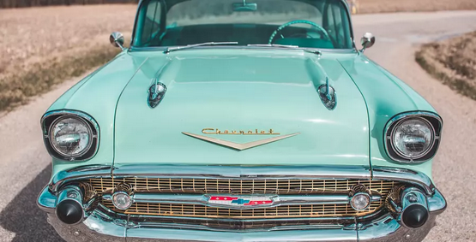
Find new roads with your Chevy.
Founded in 1911 by Louis Chevrolet and William C. Durant in Detroit, Chevrolet is today a very popular brand for classic cars all over the world. Models like the Pickup from 1946 or the famous Corvette with a V8 engine are in great demand by collectors and dealers.

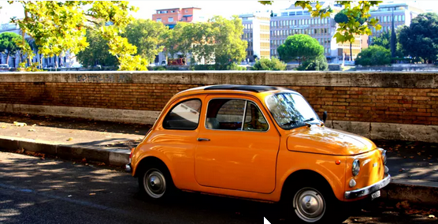
Fiat - Driven by Passion.
Fabbrica Italiana Automobili Torino
Italian lifestyle and unique designs, that's what Fiat carries out into the world. Today it's the biggest car manufacturer in Italy and also of whole Europe. Fiat has received many international awards for its cars.

